Alumnae Perception Study

# **Staying connected with the college**

## Staying connected with the faculties

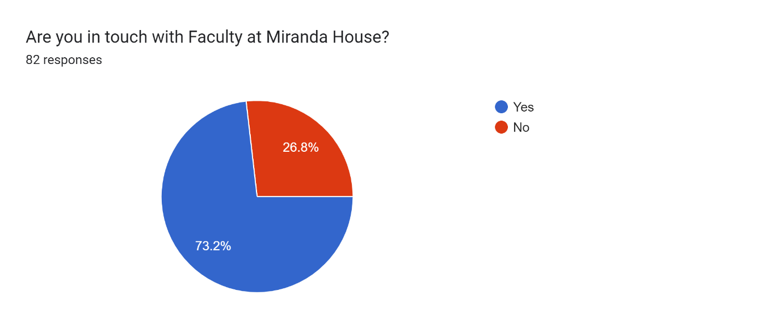

## Visiting the college campus after graduating

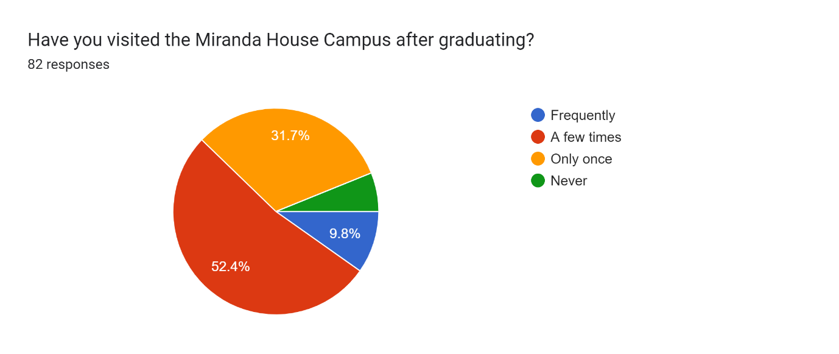

# **Cooperation towards rapid future growth of the college**

## Contribution to Miranda House

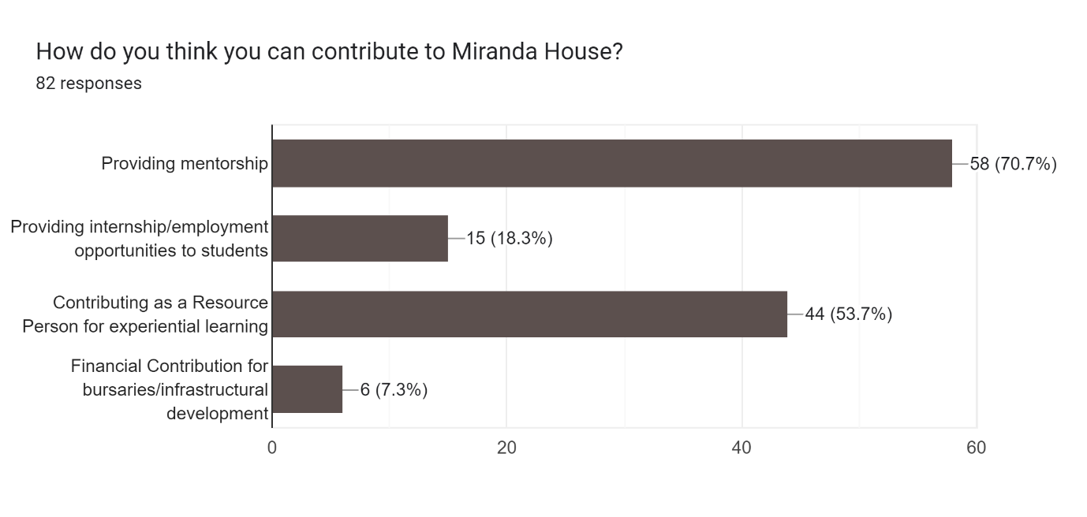

## Sponsor a student